**A)**

The forward converter with the following requirements is designed and simulated. The proper steady-state operation of the converter is verified through the Figure 1 and Figure 2 .

Vin = 24V-48V

Vout = 12V

Pout = 50W

Output Voltage Ripple = 2%

Line Regulation = 2%

Load Regulation = 2%

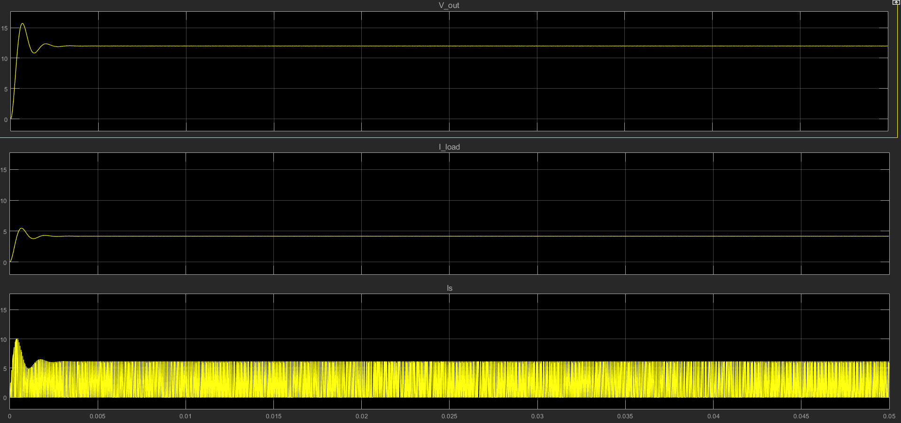

Figure 1 – Output voltage, Input and Output Current Waveforms of the forward converter.

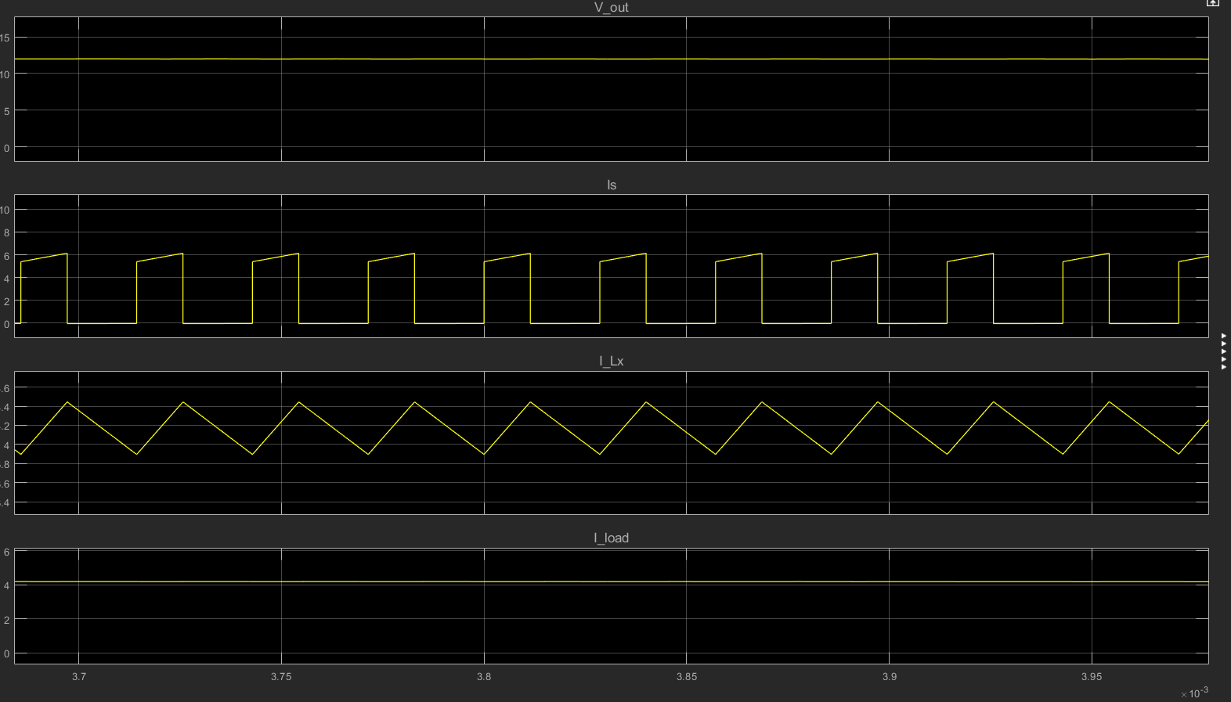

Figure 2 – Output voltage, Input, Output and Inductor current waveforms of the forward converter.